Python and Its Features

Python and Its Features

Python is a high-level, interpreted programming language known for its simplicity and versatility. It is widely used in web development, data analysis, machine learning, automation, and more.

1. Simple and Readable Syntax
2. Interpreted and Dynamically Typed: Code is executed line by line, and variables do not require explicit type declarations.
3. Extensive Libraries and Frameworks: Libraries like NumPy, Pandas, Django, and TensorFlow support a wide range of applications.
4. Portability and Cross-Platform Support: Python runs on various platforms such as Windows, macOS, and Linux.
5. Object-Oriented and Functional Programming: Supports both paradigms, allowing flexibility in software design.

Data Preprocessing Steps

Data Preprocessing Steps

Data preprocessing is a crucial step in data analytics and machine learning, as it prepares raw data for further analysis by cleaning, integrating, reducing, and transforming it. The major steps involved are as follows:

**Data Cleaning:** To identify and rectify errors, inconsistencies, or missing values in the dataset.

1. Handle Missing Data
2. Remove Noisy Data / Remove Outliers
3. Remove Inconsistencies in data
4. Remove Duplicate entries

**Data Integration:** To combine data from multiple sources into a single cohesive dataset.

1. Schema Integration: Align attributes from different sources
2. Entity Identification: Ensure entities refer to the same concept.
3. Redundancy Handling: Detects correlated attributes and removes duplicates.
4. Conflict Resolution: Address discrepancies in units or scales

**Data Reduction:** To reduce the volume of data while preserving the quality of information.

1. Dimensionality Reduction: Techniques like PCA (Principal Component Analysis) to reduce feature space.
2. Data Compression: Using encoding techniques to compress large datasets.
3. Data Sampling: Reducing data size by selecting representative subsets.

**Data Transformation:** To convert data into a suitable format for analysis.

1. Normalization: Scaling data to a uniform range
2. Encoding Categorical Data: Converting text labels into numerical values
3. Aggregation: Summarizing data to obtain key insights

**Data Discretization:** Data discretization is the process of converting continuous data into discrete buckets or intervals.

1. Binning
2. Cluster Analysis
3. Histogram Analysis
4. Decision Tree Discretization
5. Quantile-Based Discretization

Python Libraries for preprocessing

Discuss essential python libraries for preprocessing

1. Data preprocessing is a critical step in any data-driven project, transforming raw data into a clean and suitable format for analysis and machine learning model building.
2. Python, with its rich ecosystem of libraries, offers powerful tools for this purpose. Among the most essential are NumPy, Pandas, SciPy, and Scikit-learn, each playing a distinct yet complementary role in the preprocessing pipeline.

**NumPy (Numerical Python)**

1. NumPy provides a vast collection of mathematical functions that can operate directly on arrays. These are essential for tasks like numerical transformations, statistical calculations (mean, median, standard deviation), and generating numerical data.
2. NumPy's ndarray objects allow for fast and vectorized operations, which are significantly more performant than standard Python lists for numerical computations. This efficiency is crucial when dealing with large datasets

**Pandas**

1. Pandas is used for data manipulation and analysis, providing high-level data structures and functions designed to make working with structured or tabular data intuitive and flexible.
2. Pandas Series and Dataframe are ideal for handling real-world datasets
3. It offers a rich set of tools for data cleaning: Handling missing values, Data type conversion, Duplicate removal, Filtering data, etc
4. It also provides tools for data transformations like apply, map, merge, join, etc
5. Functions like describe() are used for Exploratory data analysis (EDA)

**SciPy (Scientific Python)**

1. SciPy builds upon NumPy and provides a large collection of algorithms and functions for scientific and technical computing.
2. Used for numerical integration, optimization, interpolation, and signal processing.
3. Statistical tests can be done to detect outliers (e.g z-score)
4. Data transformation can be performed to stabilize variance and make data more normally distributed

**Scikit-learn (Machine Learning Library)**

1. It offers a comprehensive suite of tools specifically designed for data preprocessing, found primarily in its sklearn.preprocessing module
2. Scaling using StandardScalar, MinMaxScalar, RobustScalar
3. Encoding Categorical Features using LabelEncoder, OrdinalEncoder, OneHotEncoder
4. Handling missing values using SimpleImputer, KNNImputer
5. Binning using KBinsDiscretizer

**Scikit-learn** delivers a robust and comprehensive toolkit for common preprocessing tasks essential for preparing data for machine learning, such as scaling, encoding, imputation, and feature engineering, along with mechanisms for creating reproducible preprocessing workflows

Handling Missing Data

Handling Missing Data

1. Missing data is a common issue in data analysis and can arise due to various reasons, such as human error, equipment malfunction, or data extraction problems.
2. Proper handling of missing data is essential to maintain data quality and ensure the accuracy of analysis.

**Ignore the tuple**:

1. This is usually done when the class label is missing
2. This method is not very effective, unless the tuple contains several attributes with missing values.
3. By ignoring the tuple, we do not make use of the remaining attributes’ values in the tuple

**Use a global constant:**

Replace all missing attribute values by the same constant such as a label like “Unknown” or -1

**Filling Missing Values:**

1. Mean/Median/Mode Imputation: Replaces missing values with the mean, median, or mode.
2. Interpolation: Uses the trend or pattern in data to estimate missing values.
3. K-Nearest Neighbors (KNN) Imputation: Fills missing values based on the nearest data points.
4. Regression Imputation: Predicts missing values using regression models.

**Using Algorithms That Handle Missing Data:**

Some algorithms, like XGBoost or Random Forest, can natively manage missing data. No explicit imputation is needed when using these methods.

Removing Duplicates from Dataset

Removing Duplicates from Dataset

Duplicates in a dataset occur when the same record appears more than once, either completely or partially. This redundancy can skew analysis results and lead to incorrect conclusions.

**Identify Duplicates**

1. Check for identical rows (all columns matching).
2. Detect partial duplicates (key columns like ID, name, or timestamp matching).

**Decide on a Removal Strategy**

1. Keep First/Last Occurrence: Retain the first or last duplicate entry.
2. Aggregate Data: Combine duplicates (e.g., sum sales values).
3. Manual Review: Verify before deletion if duplicates may contain useful variations.

**Impact of Duplicates:**

1. Statistical Bias: Skews mean, median, and other statistical metrics.
2. Machine Learning Issues: Redundant data can make models overfit or produce biased predictions.
3. Resource Wastage: Increases storage and processing time.

Example of duplicates:

| **EmployeeID** | **Name** | **Age** | **Department** |
| --- | --- | --- | --- |
| 101 | Alice | 30 | HR |
| 102 | Bob | 25 | IT |
| 101 | Alice | 30 | HR |
| 103 | Charlie | 28 | Marketing |

Here, the first and third rows are exactly identical, meaning the same employee data is recorded twice.

df = df.drop_duplicates()

Data Transformation

Write a short note on Data Transformation

Data Transformation is process of converting data from its raw form into a suitable format for analysis

**Smoothing:**

Purpose: To remove noise from data.

Techniques:

**Binning**: Groups values into bins to reduce noise.

**Regression**: Fits a line or curve to the data points to identify trends.

**Clustering**: Groups similar data points to minimize variance.

**Attribute Construction (Feature Construction):**

Purpose: To create new attributes from existing ones

Example: Combining "height" and "weight" to create a new attribute "BMI" (Body Mass Index).

**Aggregation**:

Purpose: To summarize data by performing aggregation operations.

Example: Aggregating daily sales data to calculate monthly and annual totals.

**Normalization**:

Purpose: To scale attribute values to a smaller range.

Common Ranges:

[-1.0, 1.0]

[0.0, 1.0]

**Discretization**:

Purpose: To convert continuous numeric data into categorical intervals.

Example:

Numeric Values: Age (0–10, 11–20, etc.)

Conceptual Labels: Youth, Adult, Senior

**Concept Hierarchy Generation for Nominal Data**:

Purpose: To generalize attributes into higher-level concepts.

Example: Street → City → Country

Analytics Types

Analytics Types

Analytics is categorized into four main types based on complexity and purpose:

**Descriptive Analytics** (What happened?)

1. Summarizes historical data to identify trends and patterns.
2. Techniques: Data aggregation, data mining, and reporting.
3. Uses dashboards, reports, and visualization tools (e.g., Excel, Tableau).
4. Example: Monthly sales reports, website traffic analysis.
5. Usage: Understanding past performance and gaining insights from previous data.

**Diagnostic Analytics** (Why did it happen?)

1. Investigates causes behind past outcomes using drill-down and correlation analysis.
2. Techniques: Root cause analysis, data mining, and SQL queries.
3. Example: Identifying why customer churn increased by analyzing user feedback.
4. Usage: Discovering root causes of anomalies or unexpected results.

**Predictive Analytics** (What is likely to happen?)

1. Forecasts future trends using statistical models and machine learning.
2. Tools: Regression, time-series forecasting, and AI (e.g., Python, R).
3. Example: Predicting stock prices or customer churn probability.
4. Usage: Anticipating trends and making data-driven forecasts.

**Prescriptive Analytics** (What should be done?)

1. Recommends actions to optimize outcomes using optimization and simulation.
2. Techniques: Decision trees, recommendation engines, and A/B testing.
3. Example: Personalized marketing strategies, supply chain optimization.
4. Usage: Making proactive decisions to optimize future outcomes.

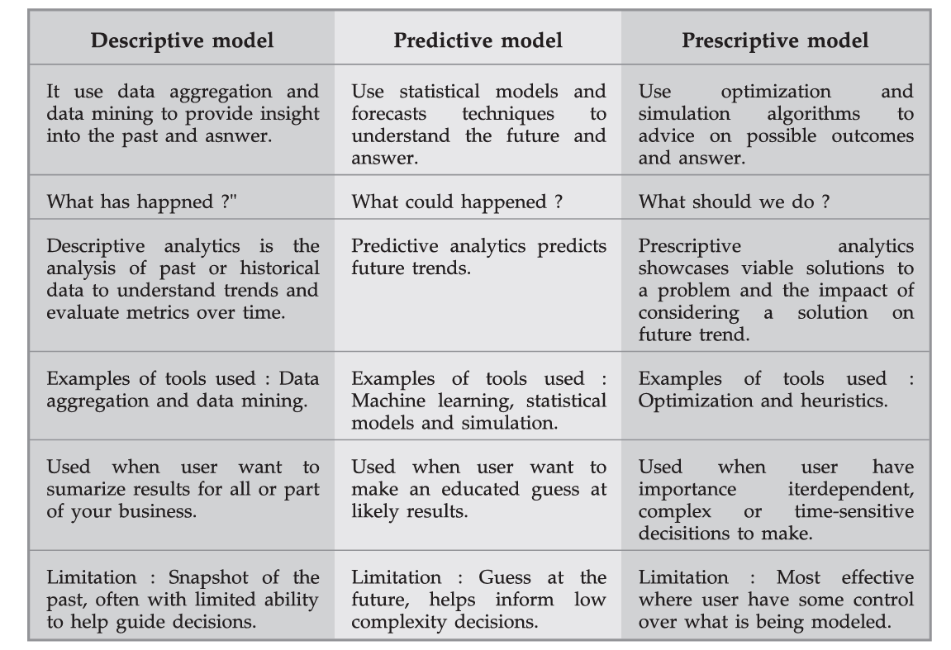

Association Rules

Association Rules

1. Association rule mining is an unsupervised learning technique
2. It analyzes unlabeled transactional data to find patterns or relationships among variables.
3. It is a descriptive method often used to discover interesting relationships hidden in a large dataset
4. The goal with association rules is to discover interesting relationships among the items. (The relationship occurs too frequently to be random and is meaningful from a business perspective, which may or may not be obvious.)
5. An association rule is an implication of the form:

If X, then Y(X→Y)

Where:

X (Antecedent): The item or set of items on the left-hand side.

Y (Consequent): The item or set of items on the right-hand side.

The rule suggests that if item X is present in a transaction, item Y is likely to be present as well.

1. A typical example is a **Market Based Analysis**

It is one of the key techniques used by large relations to show associations between items.It allows retailers to identify relationships between the items that people buy together frequently.

Given a set of transactions, we can find rules that will predict the occurrence of an item based on the occurrences of other items in the transaction.

Rule: {Bread, Butter} → {Milk}

Interpretation: If a customer buys bread and butter, they are likely to buy milk as well.

1. Rule Evaluation Metrics

**Support**: Measures the frequency of the rule within the dataset.

Support(A ⇒ B) = (Transactions containing A and B) / (Total transactions)

**Confidence:** Measures the reliability of the rule.

Confidence(A ⇒ B) = Support(A ∪ B) / Support(A)

**Lift:** Measures the strength of the rule compared to random chance.

Lift(A ⇒ B) = Confidence(A ⇒ B) / Support(B)

1. Applications:

**Market Basket Analysis**: Discovering items frequently bought together.

**Recommendation Systems**: Suggesting products based on previous purchases.

**Fraud Detection**: Identifying unusual patterns in financial transactions.

Apriori Algorithm

Apriori Algorithm

1. Apriori Algorithm is a foundational method in data mining used for discovering frequent itemsets and generating association rules.
2. Its significance lies in its ability to identify relationships between items in large datasets which is particularly valuable in market basket analysis.
3. The Apriori algorithm takes a bottom-up iterative approach.

How the Apriori Algorithm Works?

1. **Identifying Frequent Itemsets**: The algorithm begins by scanning the dataset to identify individual items (1-item) and their frequencies. It then establishes a minimum support threshold, which determines whether an itemset is considered frequent.
2. **Creating Possible item group**: Once frequent 1-itemgroup (single items) are identified, the algorithm generates candidate 2-itemgroup by combining frequent items. This process continues iteratively, forming larger itemsets (k-itemgroup) until no more frequent itemgroup can be found.
3. **Removing Infrequent Item groups**: The algorithm employs a pruning technique based on the Apriori Property, which states that if an itemset is infrequent, all its supersets must also be infrequent. This significantly reduces the number of combinations that need to be evaluated.
4. **Generating Association Rules**: After identifying frequent itemsets, the algorithm generates association rules that illustrate how items relate to one another, using metrics like support, confidence, and lift to evaluate the strength of these relationships.

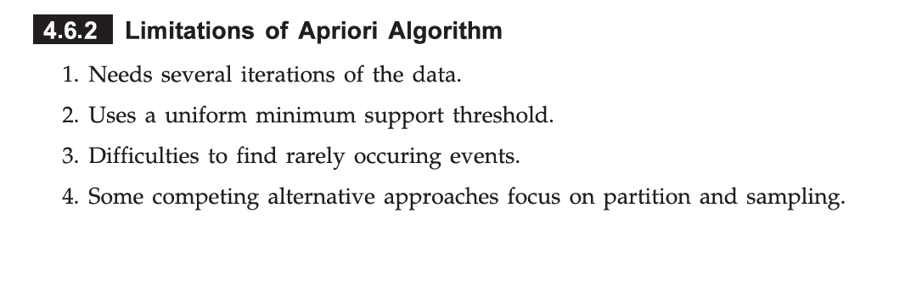

FP-Growth vs Apriori Algorithm

FP-Growth vs Apriori Algorithm

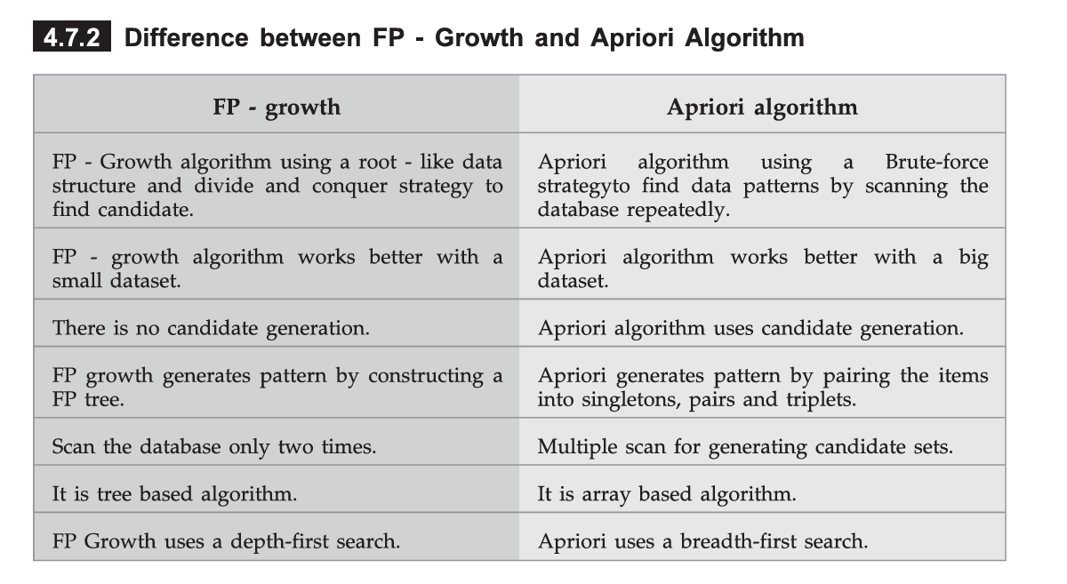

Linear Regression

What is linear regression, and what are its primary objectives? What is

the difference between simple linear regression and multiple linear

regression? How do you evaluate the performance of Linear Regression?

1. Linear Regression is a supervised learning algorithm used to predict a continuous output based on one or more input features.
2. It models the relationship between the dependent variable (Y) and one or more independent variables (X) by fitting a linear equation to the data.
3. Based on known input values, a linear regression model provides the expected value of the outcome variable based on the values of the input variables, but some uncertainty may remain in predicting any particular outcome

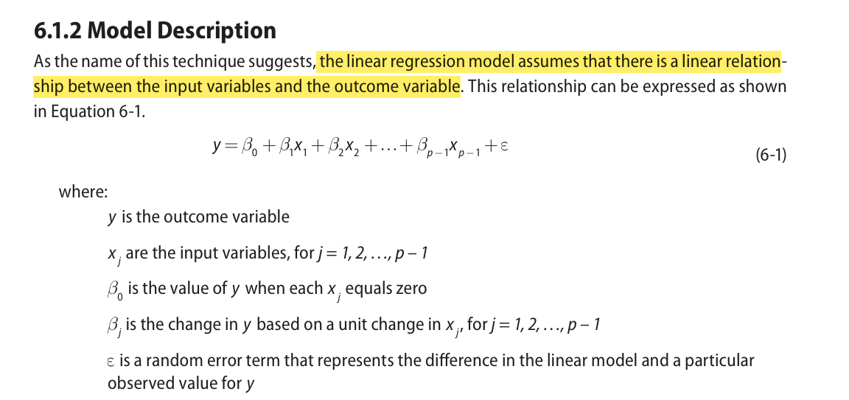

1. Suppose it is desired to build a linear regression model that estimates a person’s annual income as a function of two variables—age and education—both expressed in years.



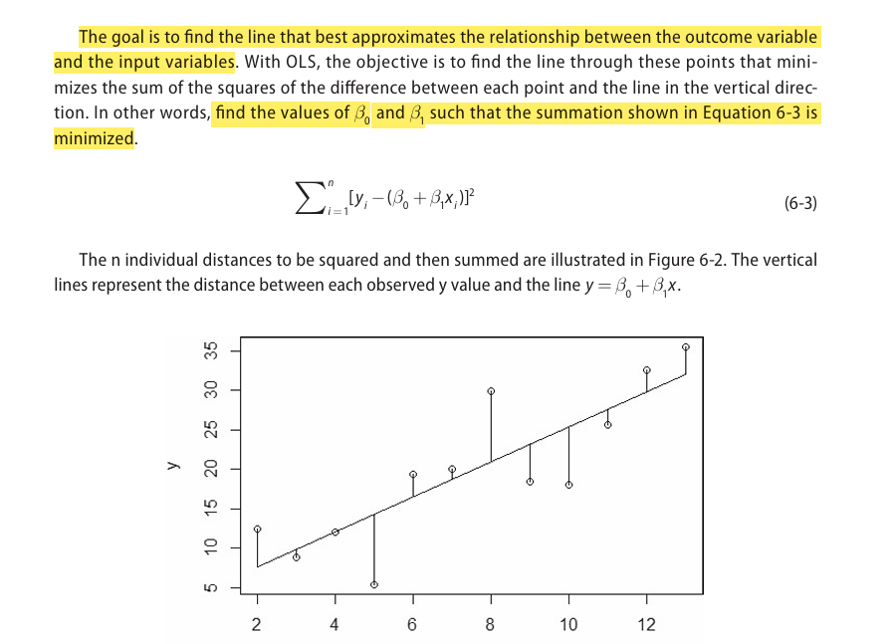

**Primary Objectives of Linear Regression**:

1. **Prediction**: Predict the value of a dependent variable based on independent variables.
2. **Relationship Modeling**: Understand how changes in independent variables affect the dependent variable.
3. **Trend Analysis**: Identify trends and relationships between variables.
4. **Forecasting**: Predict future values based on historical data.

**Performance Evaluation of Linear Regression:**

1. Mean Absolute Error (MAE):

Average of the absolute differences between the predicted and actual values.

n : is the number of data points.

: is the actual value for the i-th data point.

is the predicted value for the i-th data point.

1. Mean Squared Error (MSE):

Average of the squared differences between predicted and actual values.

1. Root Mean Squared Error (RMSE):

Square root of MSE.

Keeps the unit of error same as the dependent variable.

1. Coefficient of Determination (R²):

Measures how well the regression model fits the data.

Ranges from 0 to 1, with 1 indicating a perfect fit.

Higher R² means the model explains more variance.

SSres: Sum of squares of residuals.

SStot: Total sum of squares.

**Difference Between Simple and Multiple Linear Regression:**

| **Aspect** | **Simple Linear Regression** | **Multiple Linear Regression** |
| --- | --- | --- |
| Number of Variables | One independent variable (X) | Two or more independent variables (X1, X2, X3...) |
| Equation Form | Y = β₀ + β₁X + ϵ | Y = β₀ + β₁X₁ + β₂X₂ + ... + ε |
| Complexity | Simple and easy to interpret | More complex due to the inclusion of multiple variables |
| Example | Predicting house price based on area | Predicting house price based on area, location, and age |

Logistic Regression

What is logistic regression, and how does it differ from linear regression?

What is the sigmoid function, and what role does it play in logistic

regression?

1. Logistic Regression is a supervised learning algorithm used for binary classification problems.
2. Unlike linear regression, which predicts continuous values, logistic regression predicts the probability of a categorical outcome.
3. Logistic Regression can also be extended to handle multiple outcome categories through variations such as Multinomial Logistic Regression and Ordinal Logistic Regression.

**Working of Logistic Regression**

1. Logistic regression predicts one of two possible outcomes (like Yes/No, 0/1, True/False).
2. **Sigmoid Function:** The algorithm uses the sigmoid function to map predicted values to probabilities:

Here, 𝑧 is a linear combination of input features:

P( y=1 ) = σ(z)

P( y=0 ) = 1 − σ(z)

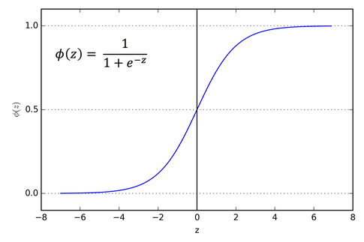

1. Set the Classification Threshold

Logistic regression typically uses a threshold value to make a decision:

If P(Y=1) ≥ 0.5, classify as Yes (1).

If P(Y=1) < 0.5, classify as No (0).

You can adjust this threshold depending on the problem (e.g., set to 0.7 if you need more certainty).

Linear vs Logistic Regression

Linear vs Logistic Regression

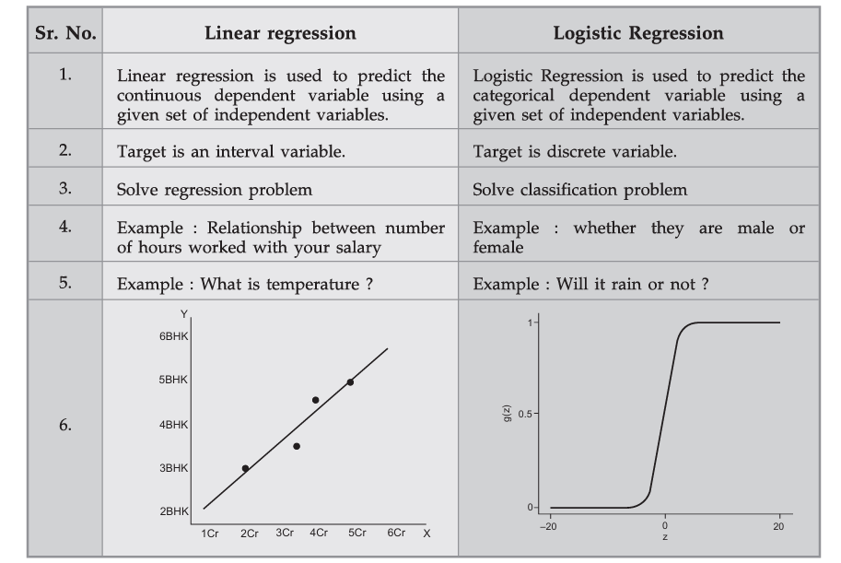

Types of Logistic Regression

Types of Logistic Regression

Logistic regression can be categorized into three main types based on the nature of the dependent variable (output):

1. **Binary Logistic Regression:**

Purpose: Predicts a binary outcome (two possible classes).

Example: Predicting whether an email is spam (1) or not spam (0).

How it works: Uses a sigmoid function to map predicted values between 0 and 1.

Decision rule: Typically, a threshold of 0.5 is used:

If P(Y=1)≥0.5 → Class = 1

If P(Y=1)<0.5 → Class = 0

2. **Multinomial Logistic Regression**:

Predicts outcomes with three or more unordered categories.

Example: Predicting the type of cuisine: Italian (1), Chinese (2), Mexican (3).

How it works: Uses a softmax function to calculate the probability of each class. The sum of probabilities for all classes equals 1.

Application: Typically used in multi-class classification problems, where the categories do not have a natural order.

3. **Ordinal Logistic Regression**:

Predicts outcomes with three or more ordered categories.

Example: Predicting customer satisfaction: Very Unsatisfied (1), Unsatisfied (2), Neutral (3), Satisfied (4), Very Satisfied (5).

How it works: Uses the concept of cumulative logits.

Estimates the probability of being at or below a certain category.

Application: Used when the classes have a meaningful order but the differences between them are not equal.

| **Type of Logistic Regression** | **Outcome Types** | **Example** |
| --- | --- | --- |
| Binary Logistic Regression | Two possible classes | Yes/No, Spam/Not Spam |
| Multinomial Logistic Regression | Three or more unordered categories | Italian, Chinese, Mexican |
| Ordinal Logistic Regression | Three or more ordered categories | Very Unsatisfied to Very Satisfied |

Naïve Bayes

Explain Naïve Bayes’ classifier and its applications.

1. Naïve Bayes is a probabilistic classification method based on Bayes’ theorem (or Bayes’ law) with a few tweaks. Bayes’ theorem gives the relationship between the probabilities of two events and their conditional probabilities.
2. A naïve Bayes classifier assumes that the presence or absence of a particular feature of a class is unrelated to the presence or absence of other features.
3. It assumes that the features are independent given the class label, which is why it is termed "naïve."
4. Despite this strong and often unrealistic assumption, it performs remarkably well in many real-world applications.
5. Bayes' Theorem:

Bayes' Theorem provides a way to calculate the posterior probability of a class given the features:

Where

* P(Y∣X): Posterior probability of class 𝑌 given predictor 𝑋
* P(X∣Y): Likelihood of predictor given class
* P(Y): Prior probability of class
* P(X): Marginal probability of predictor

**Working of Naïve Bayes’ Classifier:**

Training Phase:

* Calculate the prior probability for each class.
* Calculate the likelihood of each feature given each class.
* Store these probabilities.

Prediction Phase:

* For a given instance, calculate the posterior probability for each class.
* The class with the highest posterior probability is the predicted class.

**Types of Naïve Bayes Classifiers**

**Gaussian Naïve Bayes**:

* Assumes that features follow a Gaussian (normal) distribution.
* Used when features are continuous.

**Multinomial Naïve Bayes:**

* Suitable for discrete data, such as word counts in text classification.
* Often used in document classification and text analytics.

**Bernoulli Naïve Bayes:**

* Suitable for binary/boolean features.
* Useful in text classification when features are the presence or absence of a word.

| **Application Area** | **Description** |
| --- | --- |
| Spam Filtering | Classifies emails as spam/ham |
| Sentiment Analysis | Determines emotion behind text |
| Medical Diagnosis | Predicts diseases based on symptoms |
| Document Classification | Organizes or categorizes legal/news articles |
| Recommendation Systems | Suggests products/movies based on preferences |
| Real-time Systems | Used in fraud detection and live classification |

Decision Trees

Explain Decision Trees. Explain the process of building a decision tree? What are the criteria used for splitting nodes in a decision tree? Explain why decision tree are used. Draw a sample decision tree and explain its parts.

1. A decision tree (also called prediction tree) uses a tree structure to specify sequences of decisions and consequences.
2. It is a supervised learning algorithm used for both classification and regression tasks
3. Given input X ={ x1,x2,... } where Xi is input variable, the goal is to predict a response or output variable Y
4. The prediction can be achieved by constructing a decision tree with test points and branches.
5. At each test point, a decision is made to pick a specific branch and traverse down the tree.
6. Eventually, a final point is reached, and a prediction can be made.
7. A decision tree employs a structure of test points (called nodes) and branches, which represent the decision being made. A node without further branches is called a leaf node. The leaf nodes return class labels
8. Decision trees have two varieties: classification trees and regression trees.
9. Classification trees usu ally apply to output variables that are categorical—often binary—in nature, such as yes or no
10. Regression trees, on the other hand, can apply to output variables that are numeric or continuous, such as the predicted price of a consumer good

**Structure of Decision Tree**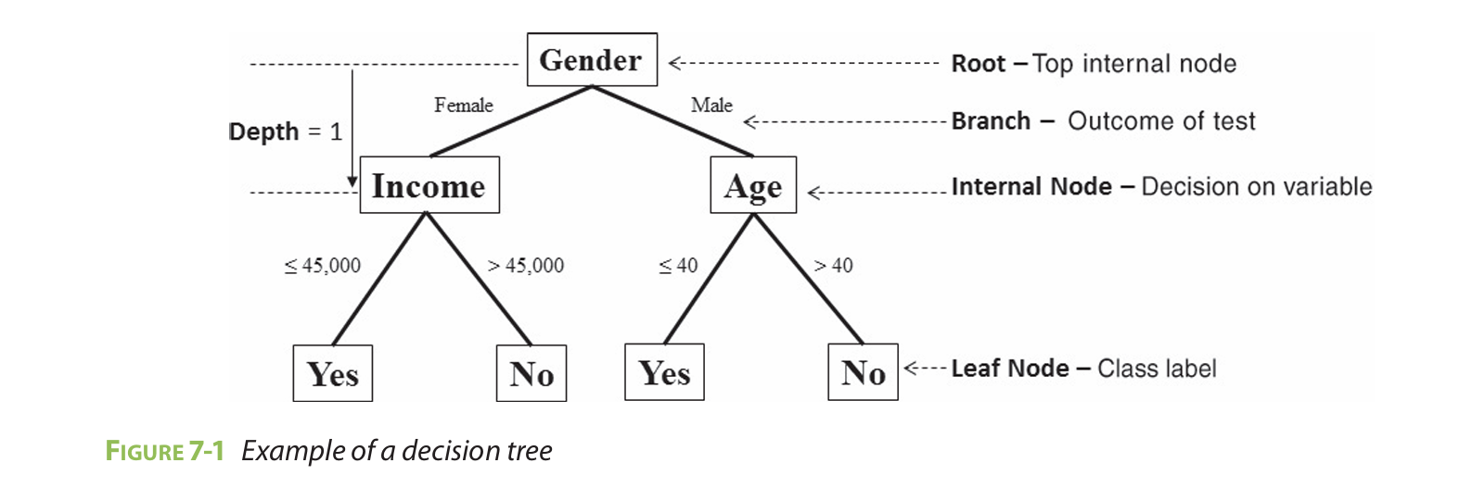

Figure 7-1 shows an example of using a decision tree to predict whether customers will buy a product.

The term **branch** refers to the outcome of a decision and is visualized as a line connecting two nodes.

If a decision is numerical, the “greater than” branch is usually placed on the right, and the “less than” branch is placed on the left.

Depending on the nature of the variable, one of the branches may need to include an “equal to” component.

**Internal nodes** are the decision or test points. Each internal node refers to an input variable or an attribute. The top internal node is called the **root**.

The branching of a node is referred to as a **split.**

The **depth** of a node is the minimum number of steps required to reach the node from the root.

**Leaf nodes** are at the end of the last branches on the tree. They represent class labels—the outcome of all the prior decisions. The path from the root to a leaf node contains a series of decisions made at various internal nodes.

### 

### 

### **Criteria Used for Splitting Nodes in a Decision Tree**

Here are the most common criteria:

| **Criterion** | **Description** | **Used In** |
| --- | --- | --- |
| **1. Gini Index** | Measures impurity: lower Gini means a purer node. | CART algorithm |
|  |  |  |
| **2. Information Gain (IG)** | Based on reduction in **entropy** (uncertainty) after a split. | ID3 algorithm |
|  |  |  |
| **3. Gain Ratio** | Improves on IG by penalizing attributes with many distinct values. | C4.5 algorithm |
|  | Gain Ratio=Information Gain / Split Info |  |
| **4. Mean Squared Error (MSE)** | Used in regression trees. Measures variance between actual and predicted values. | CART for regression |

**Why Decision Trees are Used:**

**Easy Interpretation**:Decision trees are intuitive and can be visualized, making them easy to understand.

**Handling Both Categorical and Numerical Data**: Suitable for a wide range of data types without requiring data transformation.

**No Need for Feature Scaling**: Unlike algorithms like SVM or KNN, decision trees do not require scaling of data.

**Versatile and Flexible**: Can be used for classification (like predicting whether an email is spam) and regression (like predicting house prices).

**Handling Non-Linear Data**: Decision trees can capture complex patterns through hierarchical splitting.

**Minimal Data Preprocessing**: Can handle missing values and outliers efficiently.

**Process of Tree Building**

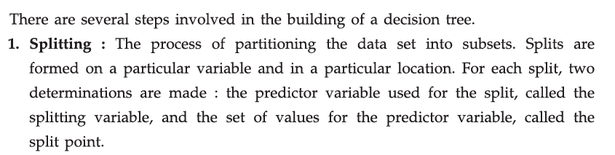

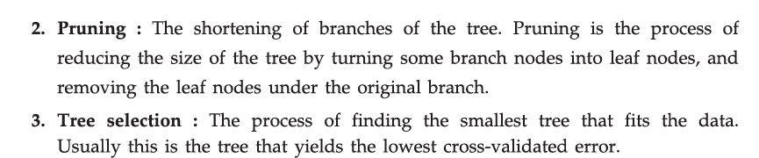

Scikit-learn library with matplotlib

### Explain scikit-learn library with matplotlib with an example.

### **Scikit-learn (sklearn):**

Scikit-learn is a powerful **open-source machine learning library** in Python that provides simple and efficient tools for:

* Classification
* Regression
* Clustering
* Model selection
* Dimensionality reduction
* Preprocessing

It is built on top of **NumPy**, **SciPy**, and **Matplotlib**.

### **Matplotlib:**

Matplotlib is a comprehensive library for **creating static, animated, and interactive visualizations** in Python. It is commonly used to:

* Plot graphs
* Display charts
* Visualize model outputs

### **Using Scikit-learn with Matplotlib — Example**

Let’s understand how **Scikit-learn and Matplotlib** are used **together** to build and visualize a machine learning model.

#### **Example: Visualizing a Linear Regression Model**

import numpy as np

import matplotlib.pyplot as plt

from sklearn.linear_model import LinearRegression

# Step 1: Generate some simple data

x = np.array([1, 2, 3, 4, 5]).reshape(-1, 1) # Feature

y = np.array([2, 4, 5, 4, 5]) # Target

# Step 2: Create and train the model

model = LinearRegression()

model.fit(x, y)

# Step 3: Predict using the model

y_pred = model.predict(x)

# Step 4: Visualize the data and regression line using matplotlib

plt.scatter(x, y, color='blue', label='Actual Data')

plt.plot(x, y_pred, color='red', label='Regression Line')

plt.title('Linear Regression Example')

plt.xlabel('X')

plt.ylabel('Y')

plt.legend()

plt.grid(True)

plt.show()

### **✅ Explanation of the Code:**

* **Scikit-learn** is used to create and train a linear regression model.
* **Matplotlib** is used to:  
  + Plot the original data points as a scatter plot.
  + Draw the regression line predicted by the model.
  + Add labels, title, and legend for better understanding.

### **Why Use Scikit-learn with Matplotlib?**

* **Model Building + Visualization**: You can build models using Scikit-learn and **visualize**:  
  + Data distributions
  + Decision boundaries (e.g., for classifiers)
  + Regression lines
  + Confusion matrices
* **Performance Evaluation**: Matplotlib helps plot:  
  + ROC curves
  + Learning curves
  + Feature importance bars
  + Clustering results